Background and Significance

Importance and Relevance

The ultimate goal of this project is to remove long-standing barriers to video media access for blind and visually-impaired consumers. It would be impossible to overstate the importance of video information in modern life, with the proliferation of cable and satellite channels, rapid distribution of movies, ready availability of desktop tools for digital video production, and ever-increasing video content on the web. Indeed an expanding proportion of content delivered via the Internet is in video form. Most of this expanding universe of information is inaccessible to blind and visually impaired people because key visual elements of the video presentation inevitably lack audio equivalents. This lack of access constitutes an ever-higher barrier to effective rehabilitation in education, employment and societal participation by those with visual disabilities.

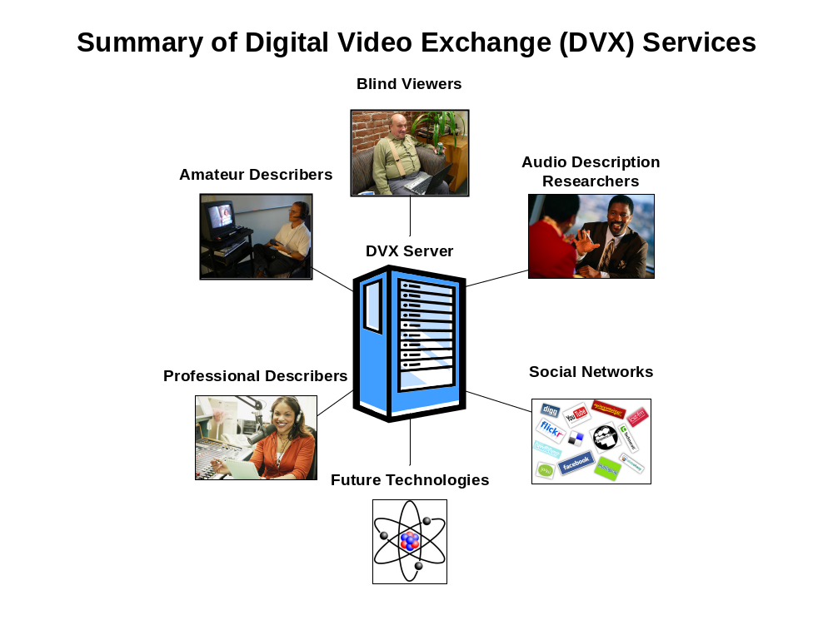
Figure 2: Illustration of the various stakeholders who stand to benefit from the development of the Descriptive Video Exchange.

This project’s specific aims seek to develop a simple, Internet-based framework to allow the creation and sharing of amateur video descriptions. This flexible sharing framework – the Descriptive Video Exchange (DVX) – will enable any movie fan or viewer to record a synchronized commentary while watching a movie on his or her computer. A blind consumer later watching the same movie on his/her own computer will seamlessly be able to link to such commentaries and listen to them in sync with the video. This will open enormous opportunities for researchers to study the practice and effectiveness of amateur video description in a wide variety of vision rehabilitation contexts including education, employment, and entertainment. If a scientifically rigorous system for the creation and distribution of described video materials can be established, not only will scientists learn more about the practice of amateur description, but the opportunities for enhanced video access by the blind will be enormous.

Current Knowledge and Practice

Unlike captioning for deaf viewers, there are currently no federal regulations requiring audio description of any type of video content (Danielson, 2003). In the absence of any requirements for audio description, many film and video publishers feel no obligation to make their content accessible for the over 21 million Americans with visual disabilities (National Center for Health Statistics, 2006). This is understandable, as the current cost of professional description services is between $1800 and $2500 per program hour (Clark, 2007; Stovall, 2009). Grant funding for audio description is also limited. The department of Education provides some level of support for the description and distribution of educational video content (approximately $5 million annually).

However, the available funding is far outstripped by the amount of material in need of description, and this problem is only becoming more severe as the production of video materials accelerates. Over the last two decades the size of the audio description industry, and the amount of federal funding available for description, have remained relatively constant in size while the amount of video information being produced has vastly increased. In effect, this has led to a bottleneck situation in which ever more information is being produced while a smaller and smaller proportion is accessible to blind consumers.

Despite this lack of mandates and funding, some major modern movies are still released in theaters with the inclusion of audio description. Unfortunately, this is still a vast minority of releases, and fewer than 10% of the over 6 thousand theaters in the U.S. are equipped with the costly description infrastructure necessary to take advantage of these descriptions (NCAM, n.d.; Datasat Digital Entertainment, 2009; IBIS World, 2009). As a finishing touch to the problem, to date, none of the descriptions prepared for such theater releases have been included as playback options on the movie’s DVD release.

Although there are no official standards or guidelines for audio description in the United States, several leaders in the field have developed their own recommendations in an effort to provide consistency and quality. Nevertheless, there is no consensus on which of these guidelines should be used in which contexts. The Media Access Group at WGBH, a research leader in audio description, has documented a “frequently asked questions” about their Descriptive Video Service (Media Access Group at WGBH, n.d.). AD International (2003), a group that promotes and supports audio description, offers an alternative set of guidelines with recommendations regarding what to describe, how to describe it, and preparation suggestions. The American Council of the Blind (2009) offers yet another set of audio description standards including myriad details on techniques for audio describers. By far the most comprehensive resource on audio description was developed under a mandate from the British government by the British Independent Television Commission in 2000. Although all are primarily intended to address the training and style management of professional describers, many of the recommendations proposed in this voluminous and confusing array of guidelines can be adapted to inform the work of amateur describers. Indeed, the results of our proposed research will provide much information about the effectiveness of information and training materials for such amateurs.

A major barrier to the investigation of amateur description is the lack of available tools for recording and distributing described content. Although a number of audio description software packages are available, none is intended for casual use by amateurs. They universally utilize a daunting video editing-style interface with complex schemes for loading and saving projects, identifying gaps in the dialog, composing scripted descriptive segments, and mixing descriptive audio clips with the original sound track. Some of the tools such as Magpie from WGBH, and Swift Adept from Softel, Inc., have extensive captioning capabilities as well, with the added interface complexity that such additional features require. Only one available description utility – LiveDescribe, from The Center for Learning Technology at Ryerson University in Toronto – includes the ability to share description segments through an associated web site. Still, LiveDescribe has a non-intuitive user interface for the recording of description, and requires blind and visually-impaired users to be skilled screen reader and web browser users.

Other available description utilities include CapScribe from the Adaptive Technology Resource Center at the University of Toronto, and JW FLV Player from the University of Washington. None of these technologies make it possible for amateur describers to easily create and share descriptions, nor do they allow blind and visually-impaired users to easily obtain and enjoy them. Yet this is exactly what is needed in order to study and promote the practice of amateur description, and this is what the proposed project aims to achieve.

Although the pace of scientific study of description creation and consumption has been slow, a number of researchers have recently been making exciting and interesting contributions. Audio description had its beginnings in the early 1970s, yet little of note was published on description techniques until the mid 1980s (Pfanstiehl, 1985). The early ‘90s saw a number of technical publications regarding techniques for embedding audio description in the broadcast television signal, both in the United States (Gerrey, 1990A; Gerrey, 1990B), and Europe (Lodge, 1992; Lodge, 1993; Pledge, 1993; Lodge, 1994; Pledge, 1994).

It was not until the mid 1990s, almost a quarter century after the introduction of the idea of audio description, that researchers finally began to concern themselves with the rigorous evaluation of descriptive content and its effectiveness for blind and visually-impaired viewers (Peli, 1996; Pettitt, 1996). These studies found that, while description can enhance the ability of blind and visually-impaired viewers to understand video content, a great deal depends on the execution of the description. As the availability of audio description increased, researchers began publishing on a number of interesting and important aspects of audio description including the demographics of the audience (Packer, 1997), its effectiveness for education (Schmeidler, 2001), and the effectiveness of alternate approaches to what has now become “traditional,” description methods (Fels, 2006; Udo, 2009A; Udo, 2009B; Udo, 2009C; Lopez, 2009). Some researchers have even begun to wonder if amateur describers, given the proper tools, could be just as effective as traditional, scripted, professional description (Branje et al, 2006). A number of additional studies have grown up around audio description, including investigation of associated discourse analysis (Benecke, 2007; Braun, 2007; Salway, 2007), automated translation techniques (Vera, 2006), and automated video cataloging and annotation (Turner, 2008; Gagnon, 2009).

We find the work of Branje and Fels extremely compelling (see Preliminary Studies), and it is their preliminary research in the area of amateur description that this proposal seeks to expand upon. The development of the DVX platform will greatly facilitate this continued investigation. It will also, in one way or another, contribute to the advancement of all of the above areas of description research. It will do so by providing a seamless platform for the production and exchange of descriptions by amateurs and professionals, along with a mechanism for easily sharing and evaluating the descriptions. This, along with the results of our research, will be a significant interdisciplinary contribution.

Advancement of Knowledge and Practice

Without DVX or a similar system, it would be almost impossible to study amateur description effectively. This is because such research requires a variety of video content to be described by a diverse group of amateur describers, and finally evaluated by members from a representative sample of the blind and visually-impaired population. Ideally, large numbers of video titles, volunteer describers, and description consumers will be involved. The proposed DVX platform is ideally suited to these needs in a way that no other audio description tools have yet been.

The proposed research will make use of the DVX platform to advance the knowledge and practice of amateur description in several ways. Our first experiment will allow direct comparisons between professional and amateur descriptions. Although there is promising preliminary research into the acceptability of amateur description, (Branje, 2006), no explicit, large-sample comparisons between amateur and professional description has yet been performed.

In addition to advancing the general knowledge and understanding of raw amateur description, we plan to research two other questions, both of which could have a broad impact on the future availability and palatability of amateur description – outcomes which will in turn positively impact rehabilitation of the blind and visually impaired. In the first, we plan to evaluate the effectiveness of a set of Enhanced Playback tools. These are software functions built into the DVX Player with the aim of automatically minimizing common errors in amateur descriptions – for example, accidental interruption of dialog. We hypothesize that some Enhanced Playback functions (described in later sections) will lead to improved viewer comprehension. Finally, the proposed research will investigate several innovative approaches to recruiting amateur describers by linking DVX through an application program interface (API) to modern social networking platforms (e.g., Twitter, Facebook, Second Life, etc.). If this viral marketing concept is effective for DVX, the amount of available amateur description content, as well as the number of participants, could grow exponentially as “friends,” of participants learn about the system and begin adding to and benefitting from the available video descriptions. Given the proliferation and popularity of wikis, blogs, and other user-generated content web resources, along with a well-established history of volunteerism in the service of the blind, we have good reason to anticipate the success of this model.

In short, if we are successful in developing DVX, and our research hypotheses are correct, the proposed system stands to completely revolutionize video accessibility for blind and visually-impaired consumers.

